# **Training Portal**

### Version 1.1

**Version History**

|  |  |  |  |  |  |
| --- | --- | --- | --- | --- | --- |
| **Version & Date** | **Date** | **Prepared / Revised By** | **Reason For Change** | **Reviewed On** | **Reviewed By** |
| **1.0** | 06/11/2015 | Prachee Pandey | Draft | 06/18/2015 | Venkat Vaddadi |
| **1.1** | 07/12/2015 | Prachee Pandey | Post Review Changes | 06/17/2015 | Venkat Vaddadi |
| **1.2** | 07/23/2015 | Prachee Pandey | Review -2 |  |  |
|  |  |  |  |  |  |
|  |  |  |  |  |  |
|  |  |  |  |  |  |
|  |  |  |  |  |  |
|  |  |  |  |  |  |

# Introduction

The objective is to build a software utility providing the trainer, trainee and admin the provision

* View the curriculum
* Log their attendance and activity
* Enroll
* Generate Reports
* Perform Assessments

# Scope

The deliverable for this project will have 3 main modules to develop

* Login
* Admin
* Trainee
* Trainer

# Modules / Components

# Section1: Login

The purpose of Login module is to authenticate the user based on their role and show them only the role perspective screens.

### Functional Requirements

|  |  |  |
| --- | --- | --- |
| Requirement | | Detail |
| 1 | Login | User comes to landing page and sees login window. |
|  |  | User enters username (email) and password to enter into the system. |
|  |  | Based on the login credential, determination will be done weather the user is Trainer, Trainee or Admin. |
| 2 | Forgot Password | When user clicks on Forgot Password, user should be directed to enter their email id. |
|  |  | User will enter the email Id and password is sent in email. |

### Screen Mock Ups

#### Figure 1.1 (Login)

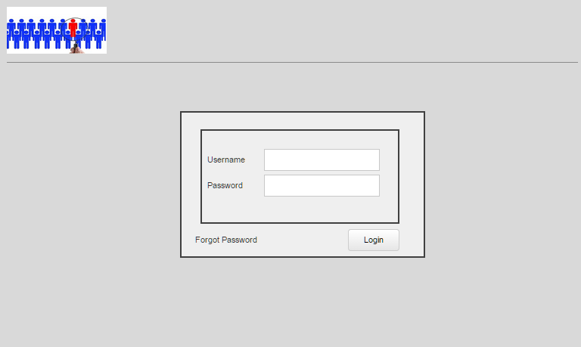

#### Figure 1.2 (Forgot Password)

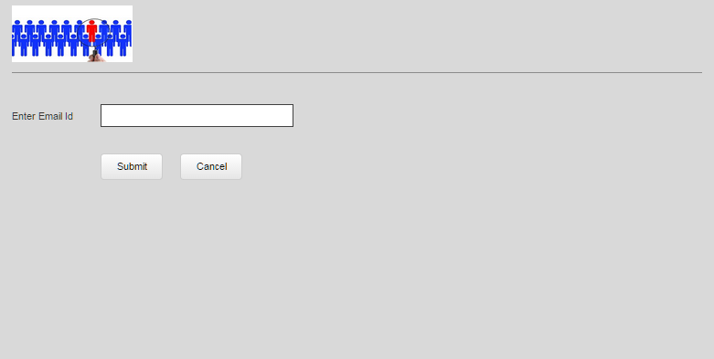

#### Figure 1.3 (Forgot Password Message)

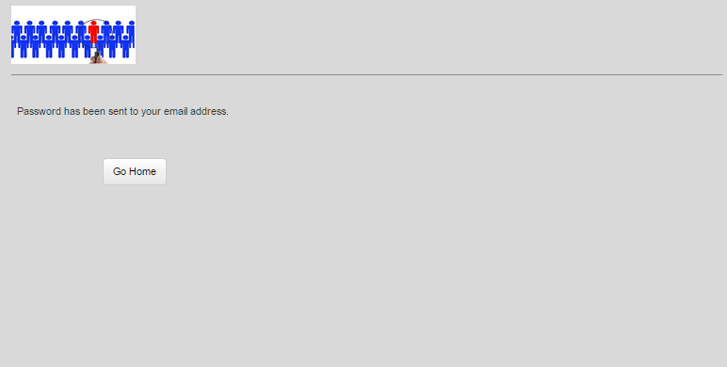

# Section 2: Admin

The purpose of the admin is to perform CRUD on Trainee, Trainer and batches for this application. The admin functionality has 3 modules

1. Manage Batches
2. Manage Trainers
3. Manage Trainees

## Manage Sessions

|  |  |  |
| --- | --- | --- |
| Requirement | | Detail |
| 1 | Search Courses | Search for any specific course by selecting the course name from dropdown |
|  |  | The search should give the data related to course as modules, duration, course duration , batch start date, batch end date |
| 2 | Edit Batch | Admin must be able to edit the above mentioned fields when edit link is clicked |
|  |  | All the fields but modules and batch can be edited |
| 3 | New Batch | New Batch can be created by selecting the course and other details |
|  |  |  |

#### Admin – Search Session (Figure 2.a.1)

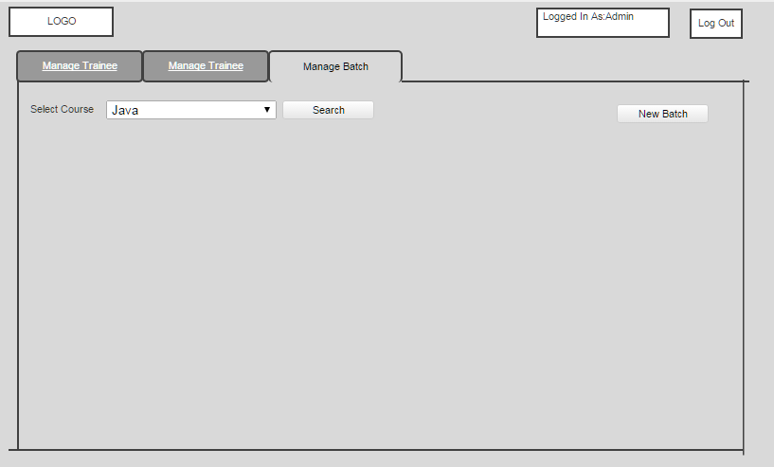

#### Admin –Session Details (Figure 2.a.2)

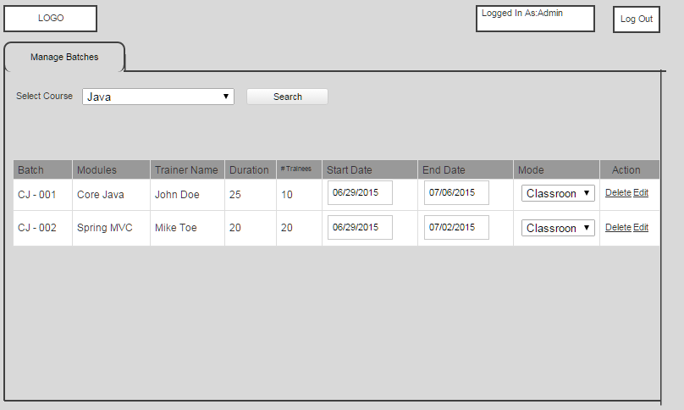

#### Admin – Edit Session (Figure 2.a.3)

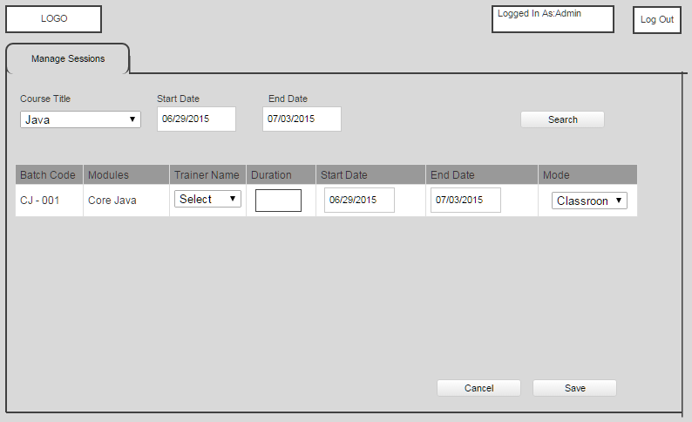

#### Admin –New Session (Figure 2.a.4)

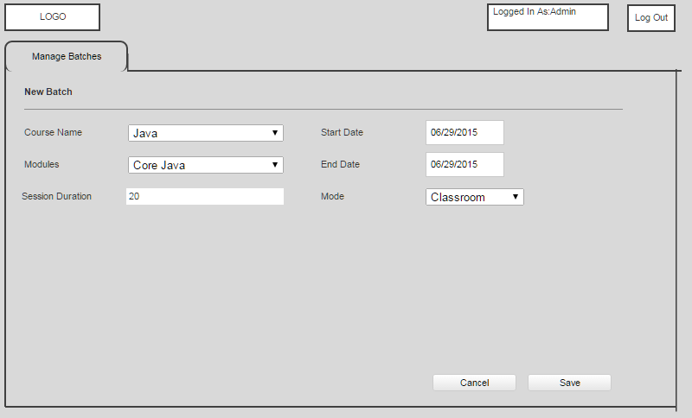

1. Manage Trainer

|  |  |  |
| --- | --- | --- |
| Requirement | | Detail |
| 1 | Search Trainer | Search for any specific trainer from the list |
|  |  | The search should give the data related to trainer as trainer name, course name, duration , batch start date, batch end date |
| 2 | View Trainer | View trainer should display all the above mentioned fields in non-editable mode |
|  |  | It should also list all the courses which the selected trainer is scheduled to take. |
|  |  | It will have a column as Credit which will allow Admin to verify and submit Trainer’s hours (Is this really required?) |
|  |  | Admin should be able to view the hours for each session with its respective dates. |
|  |  | Admin should also be able to view the demographic details of the trainer |
| 3 | Edit Trainer | Admin must be able to edit the above mentioned fields when edit link is clicked |
|  |  | The session can be deleted for the specific trainer through delete link |
| 4 | New Trainer | New trainer will be created using this functionality and all demographic details of the trainer will be added |
| 5 | Assign Batch | Batches can be assigned for the new trainer. Selection of course will auto-populate rest of the details for that course. |

#### Search Trainer (Figure 2.b1)

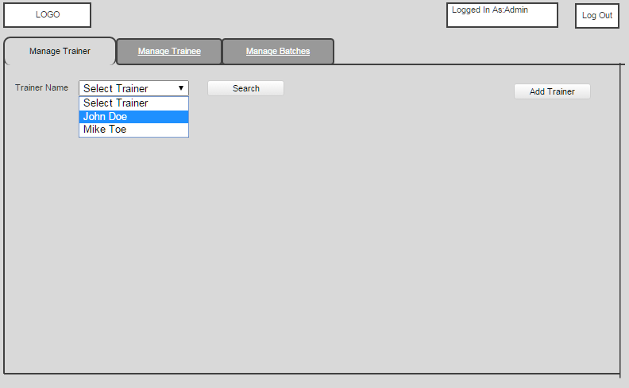

#### Search Trainer – All Courses (Figure 2.2)

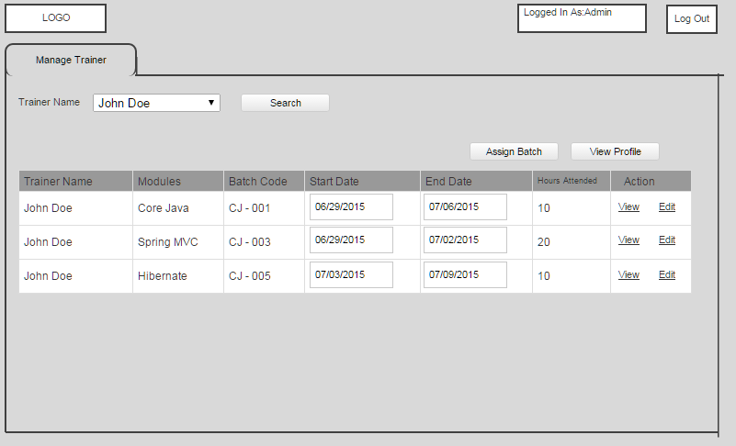

#### View Profile (Figure 2.3)

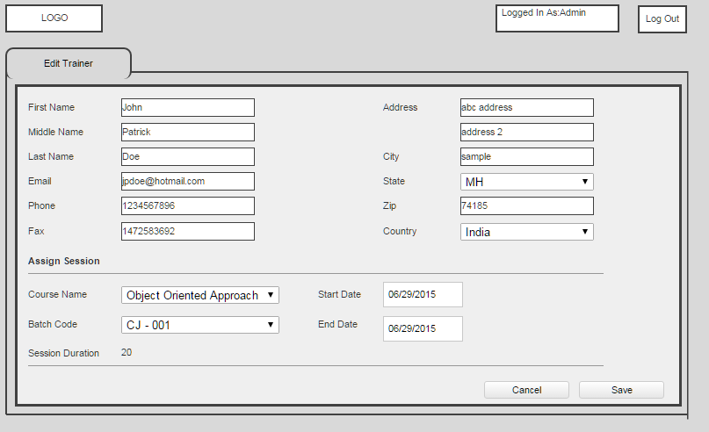

#### View Trainer – Each Course (Figure 2.4)

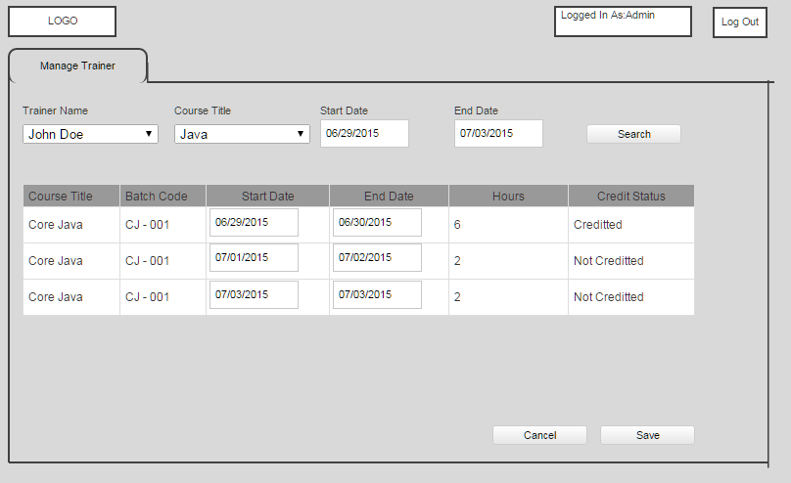

#### Edit Trainer Curriculum (Figure 2.5)

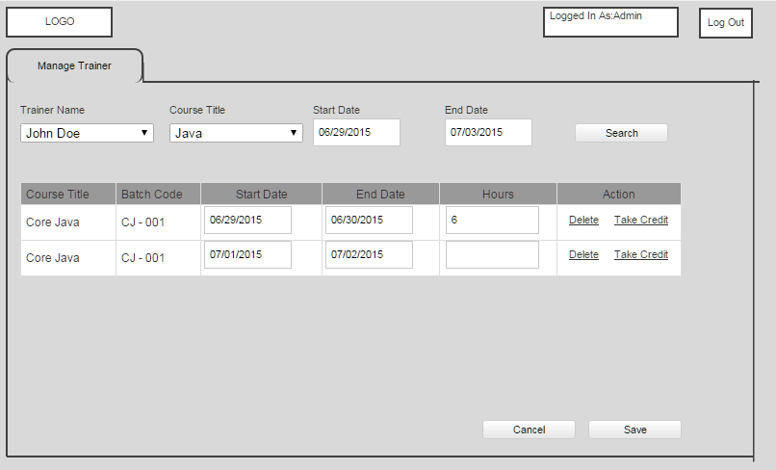

#### Add New Trainer-1 (Figure 2.6)

#### 

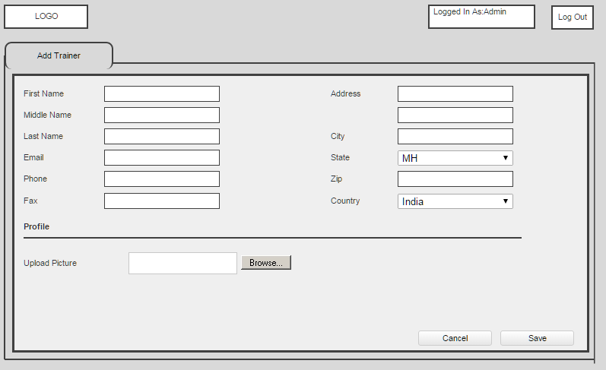

#### Assign Batch (Figure 2.6)

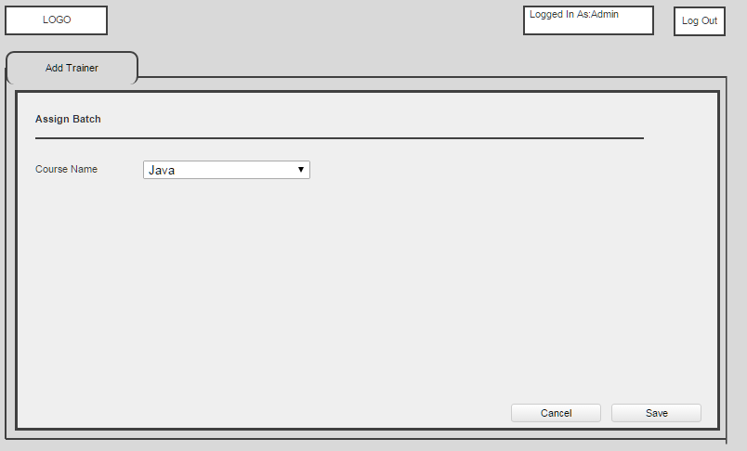

Selecting the course, will auto populate all the other details as shown below.

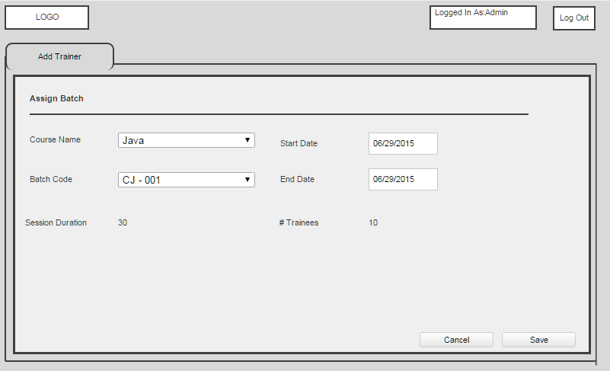

## Manage Trainee

|  |  |  |
| --- | --- | --- |
| Requirement | | Detail |
| 1 | Search Trainee | Search for any specific trainee by entering the trainee name |
|  |  | The search should give the data related to trainee as trainer name, trainee name, course name, course duration , batch start date, batch end date |
| 2 | View Trainee | View trainee should display all the above mentioned fields in non-editable mode |
|  |  | Admin should be able to view the hours attended for each session with its respective dates. |
|  |  | Admin should also be able to view the demographic details of the trainee |
| 3 | Edit Trainee | Admin must be able to edit the above mentioned fields when edit link is clicked |
|  |  | The hours can be edited for any specific course. |
| 4 | New Trainee | New trainee will be created using this functionality and all demographic details of the trainer will be added |
|  |  | Sessions can be assigned for the new trainee at the time creating profile. |

#### Admin – Search Trainee (Figure 3.1)

## 

#### Admin –Trainee List (Figure 3.1)

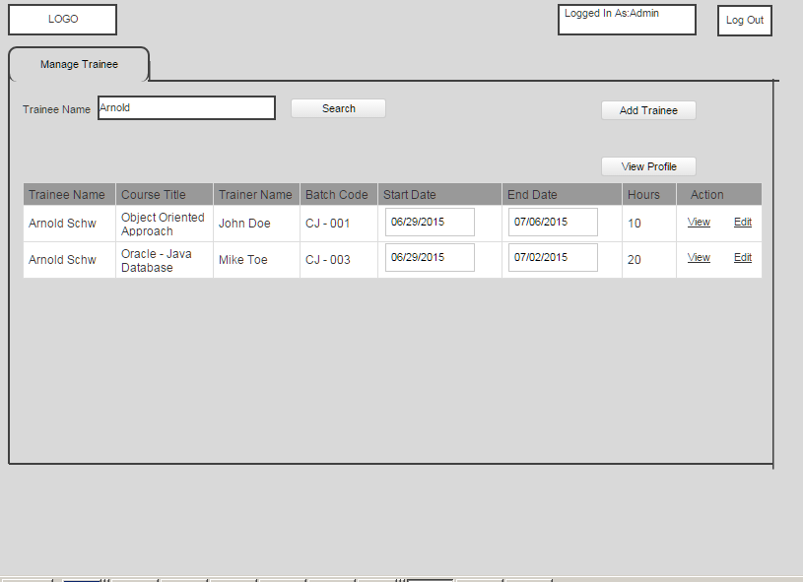

#### Admin –Trainee View (Figure 3.2)

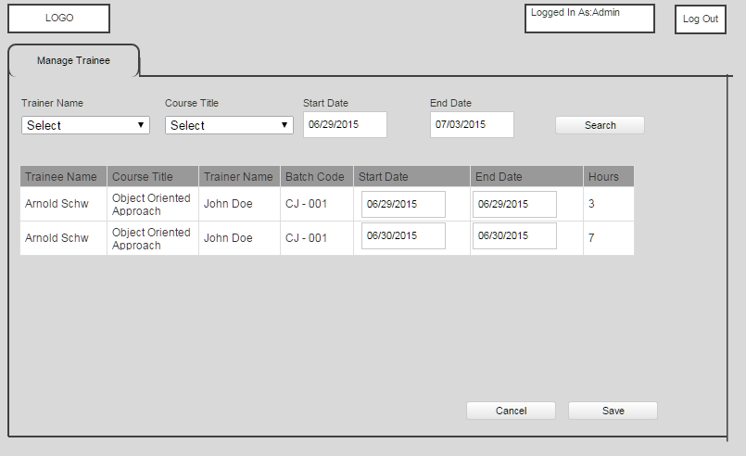

#### Admin –Trainee Edit (Figure 3.3)

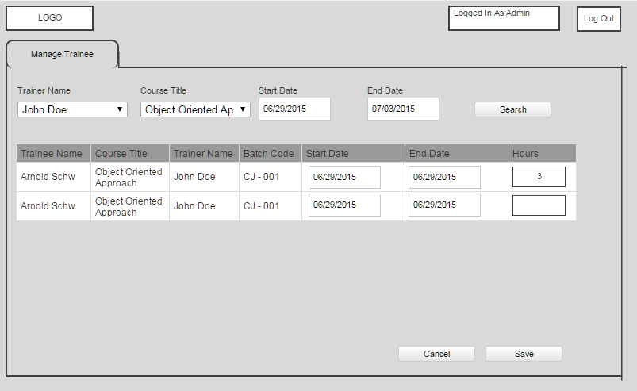

#### Admin –Add Trainee (Figure 3.3)

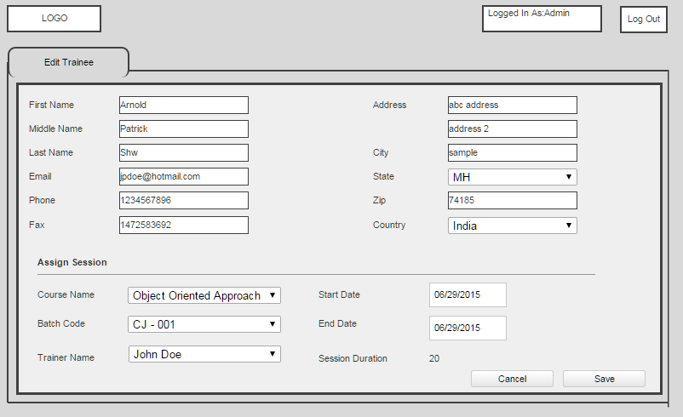

# Section Trainee

The purpose of the trainee is to allow students to enroll in the courses, log the attendance, view their training plan and take the assessment test.

### Functional Requirements

|  |  |  |
| --- | --- | --- |
| Requirement | | Detail |
| 1 | My Training | Students should be able to view their trainings which they have enrolled into. |
|  |  | It should have the search functionality to view the plan for any particular course and their module |
|  |  | Students should be able to see their trainers |
|  |  | Duration should be visible for each course |
|  |  | Training Date should be presented for student to view the dates. |
| 2 | Edit | Trainees will be allowed to edit their hours attended for any particular course. |
| 3 | My Profile | Trainees can view their demographic details |
|  |  | Trainees can edit only few fields which are phone number and email ID. |

#### Trainee – My Training (Figure 5.1)

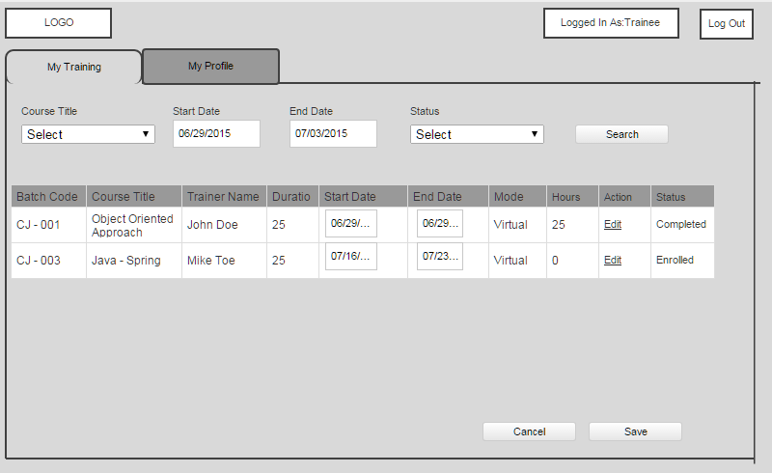

#### Trainee – Edit My Training (Figure 5.2)

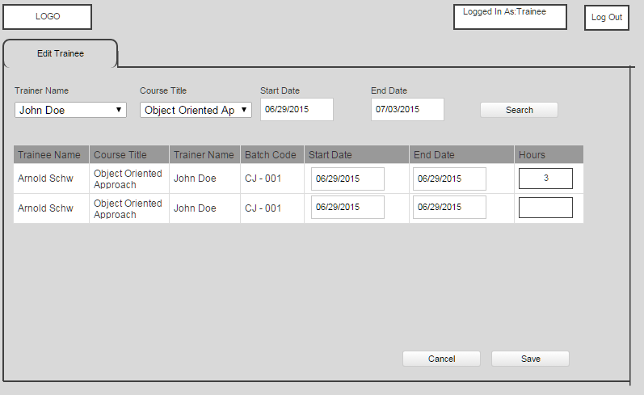

#### Trainee –My Profile (Figure 5.2)

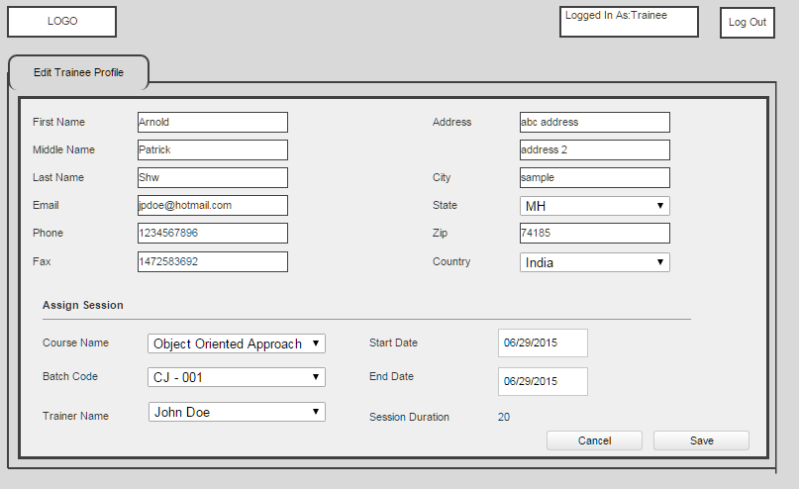

## Trainer

The trainer functionality will allow the trainers to view their curriculum, edit/update hours.

### Functional Requirements

|  |  |  |
| --- | --- | --- |
| Requirement | | Detail |
| 1 | My Training | Trainers should be able to view their trainings which they have been assigned to. |
|  |  | It should have the search functionality to view the plan for any particular course and their module |
|  |  | Trainer should be able to see the duration and other details of the course |
| 2 | Edit | Trainers will be allowed to edit their hours attended for any particular course. |
| 3 | My Profile | Trainers can view their demographic details and all the courses under this tab |
|  |  | Trainers can edit only few fields which are phone number and email ID. |

#### Trainer –My Trainings (Figure 6.1)

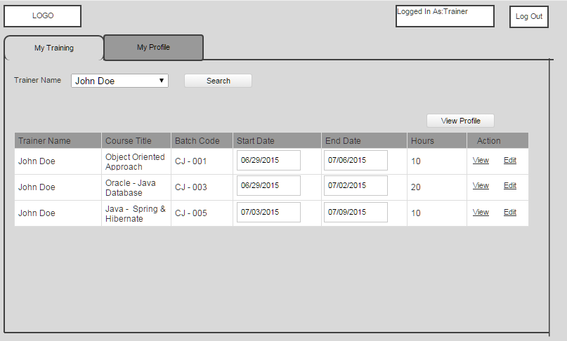

#### Trainer –View My Trainings (Figure 6.2)

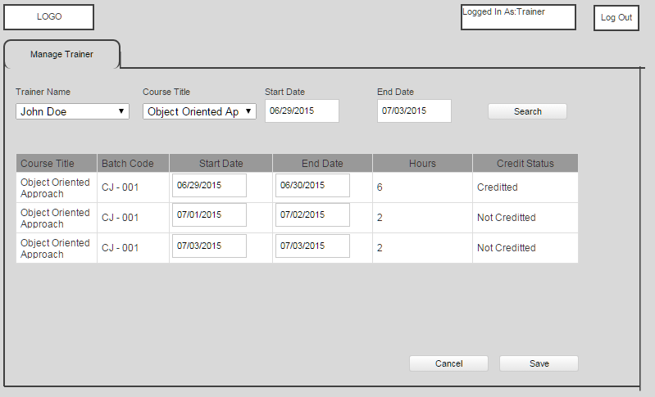

#### Trainer –Edit My Trainings (Figure 6.3)

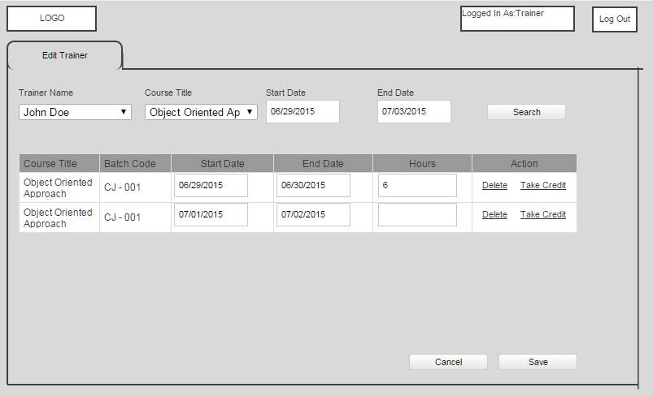

#### Trainer –Edit My Profile (Figure 6.4)

